# Introduction to end-to-end analytics using Microsoft Fabric

In this module, you'll learn how to:

* Describe end-to-end analytics in Microsoft Fabric

**Introduction**

***Microsoft Fabric*** is an end-to-end analytics platform that provides a single, integrated environment for data professionals and the business to collaborate on data projects. Fabric provides a set of integrated services that enable you to ingest, store, process, and analyze data in a single environment.

Microsoft Fabric provides tools for both citizen and professional data practitioners, and integrates with tools the business needs to make decisions. Fabric includes the following services:

* Data engineering
* Data integration
* Data warehousing
* Real-time analytics
* Data science
* Business intelligence

## **Explore end-to-end analytics with Microsoft Fabric**

***Scalable analytics*** can be complex, fragmented, and expensive. With Microsoft Fabric, you don't have to spend all of your time combining various services from different vendors. Instead, you can use a ***single product*** that is easy to understand, set up, create, and manage. Fabric offers *persona-optimized experiences* and tools in an integrated user interface.

In addition to a simple, shared user experience, Fabric is a unified **software-as-a-service (SaaS)** offering, with all your data stored in a single open format in OneLake. *OneLake* is accessible by all of the analytics engines in the platform. Fabric offers scalability, cost-effectiveness, accessibility from anywhere with an internet connection, and continuous updates and maintenance provided by Microsoft.

**Explore OneLake**

**OneLake**is Fabric's lake-centric architecture that provides a single, integrated environment for data professionals and the business to collaborate on data projects. Fabric's OneLake architecture facilitates collaboration between data team members and saves time by eliminating the need to move and copy data between different systems and teams. ***OneCopy*** is a key component of OneLake that allows you to read data from a single copy, without moving or duplicating data.

Think of it like ***OneDrive*** for data; OneLake combines storage locations across different regions and clouds into a single logical lake, without moving or duplicating data. Similar to how Office applications are prewired to use your organizational OneDrive, all the compute workloads in Fabric are preconfigured to work with OneLake. Fabric's data warehousing, data engineering (Lakehouses and Notebooks), data integration (pipelines and dataflows), real-time analytics, and Power BI all use OneLake as their native store without needing any extra configuration.

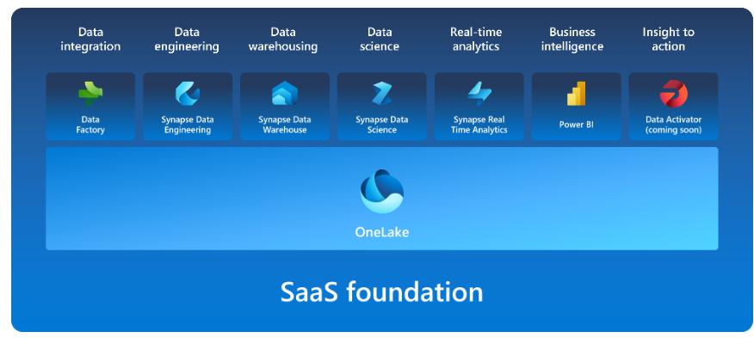

OneLake is ***built on top*** of Azure Data Lake Storage (ADLS) and data can be stored in any format, including Delta, Parquet, CSV, JSON, and more.

What this means is that all of the compute engines in Fabric ***automatically store*** their data in OneLake. Data that is stored in OneLake is then directly accessible by all of the compute engines without needing to be moved or copied. For tabular data, the analytical engines in Fabric will write data in ***delta-parquet format*** and all engines interact with the format seamlessly.

One important feature of OneLake is the ability to ***create shortcuts***, which are embedded references within OneLake that point to other files or storage locations. **Shortcuts** allow you to quickly source your existing cloud data without having to copy it, and enables Fabric experiences to derive data from the same source to always be in sync.

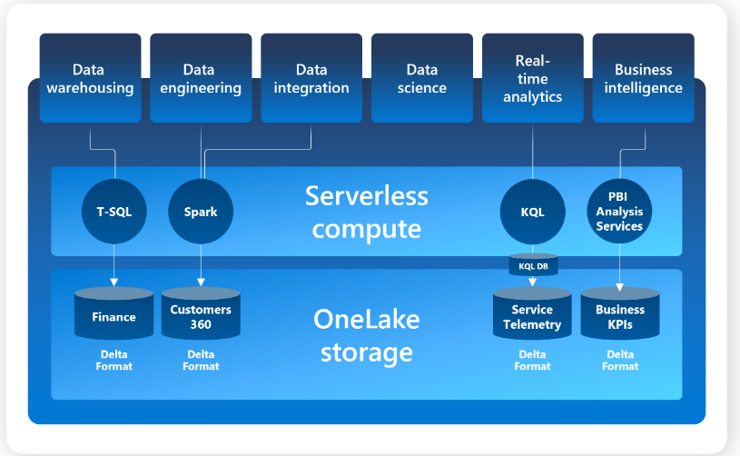

## **Explore Fabric's experiences**

Fabric offers a set of analytics experiences that are designed to accomplish specific tasks and work together seamlessly. Fabric's experiences include:

* **Synapse Data Engineering**: data engineering with a Spark platform for data transformation at scale.
* **Synapse Data Warehouse**: data warehousing with industry-leading SQL performance and scale to support data use.
* **Synapse Data Science**: data science with Azure Machine Learning and Spark for model training and execution tracking in a scalable environment.
* **Synapse Real-Time Analytics**: real-time analytics to query and analyze large volumes of data in real-time.
* **Data Factory**: data integration combining Power Query with the scale of Azure Data Factory to move and transform data.
* **Power BI**: business intelligence for translating data to decisions.

## **Explore security and governance**

Fabric's OneLake is centrally governed and open for collaboration. Data is secured and governed in one place, while remaining discoverable and accessible to users who should have access across your organization. ***Fabric administration*** is centralized in the admin center.

In the ***admin center*** you can manage groups and permissions, configure data sources and gateways, and monitor usage and performance. You can also access the Fabric admin APIs and SDKs in the admin center, which you'd use to automate common tasks and integrate Fabric with other systems.

Your *Fabric tenant* is natively integrated with Microsoft Purview Information Protection. Fabric uses *Microsoft Purview Information Protection’s* sensitivity labels to help your organization classify and protect sensitive data, from ingestion to export.

# What is Microsoft Fabric admin?

# Microsoft Fabric admin is the management of the organization-wide settings that control how Microsoft Fabric works. Users that are assigned to admin roles configure, monitor, and provision organizational resources.

# Admin roles related to Microsoft Fabric :

* **Global administrator**
  + Unlimited access to all management features for the organization
  + Assign roles to other users
* **Billing administrator**
  + Manage subscriptions
  + Purchase licenses
* **License administrator**
  + Assign or remove licenses for users
* **User administrator**
  + Create and manage users and groups
  + Reset user passwords

# Data teams and Microsoft Fabric

Microsoft Fabric's *unified management* and *governance* make it easier for data professionals to work together on data projects. Fabric *removes data silos* and the need for access to multiple systems, enhancing collaboration between data professionals.

Traditionally, the data engineer and data analyst role separation meant that there was an extra conversation that needed to happen to ensure that the engineer curated a perfect semantic model to help the analyst display data in an effective and insightful way for the business.

With Fabric, data professionals work together in the same SaaS product to better understand and identify needs of each other and the business. Further, data analysts now have greater context and ability to transform data further upstream with data factory.

Whether you're a data engineer looking to simplify your semantic model curation or expanding your knowledge with data science techniques, Fabric provides a complete experience to serve your organization.

For data analysts, who may have had to perform extensive downstream data transformations before creating Power BI reports, you can now see the lineage and connect with data more directly with **DirectLake** mode.

Data scientists now have an easier way to integrate native data science techniques and then use Power BI's interactive reporting to provide data-informed insights in a new way.

Because Fabric is a SaaS platform, it allows you to quickly and easily provision and run any type of workload or job without needing pre-approval or planning. This means that you can scale resources up or down as needed, and be more agile and responsive to changing business needs.

Lastly, Fabric is bringing the **low-to-no-code concept**, functionality, and approach that has successfully empowered many users on the Power Platform to its own SaaS offering. While it maintains scale and integrity for data science, data warehousing, data ingestion and prep, and analytics, it also offers many ways to visually represent code that previously blocked many from going further.

# Enable and use Microsoft Fabric

Before you can explore the end-to-end capabilities of Microsoft Fabric, it must be enabled for your organization. You may need to work with your IT department to enable Fabric for your organization. You'll need a trial license to use Fabric. The permissions required to enable Fabric are either:

* *Fabric admin*
* *Power Platform admin*
* *Microsoft 365 admin*

Fabric can be enabled at the tenant level or capacity level, meaning that it can be enabled for the entire organization or for specific groups of users. If you don't have access to Fabric, contact your Fabric administrator to find out if it's available to you. Note that the Fabric administrator is a new role as of June 2023. This was formerly the Power BI administrator role.

## **Check your access**

If you'd like to check to see if you have access to Fabric in your organization's tenant, sign-in to Power BI and look for the **Power BI icon** in the bottom of the left navigation pane. If you see the Power BI icon, select to see the experiences available within Fabric. If the icon isn't present, Fabric is not available to you.

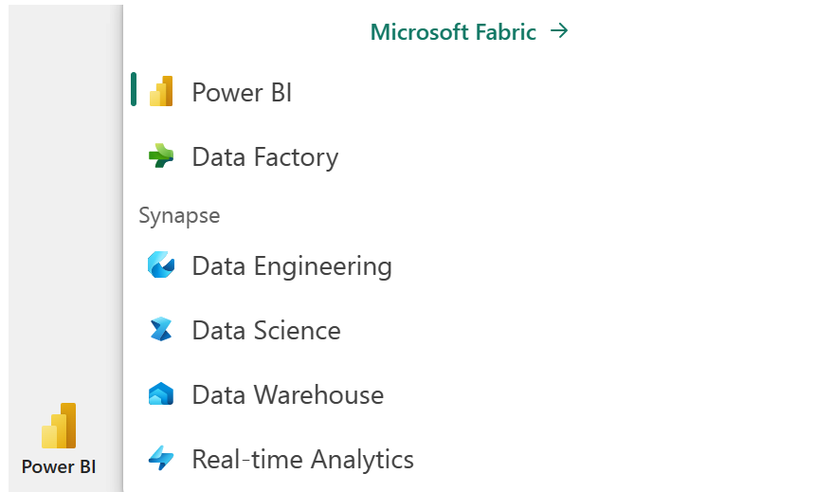

## **Enable Microsoft Fabric**

If you have admin privileges, you can access the **Admin center** from the **Settings** menu in the upper right corner of the Power BI service. From here, you enable Fabric in the **Tenant settings.**

Admins can make Fabric available to either the entire organization or specific groups of users, who can be organized based on their Microsoft 365 or Microsoft Entra security groups. Admins can also **delegate**the ability to enable Fabric to other users, at the capacity level.

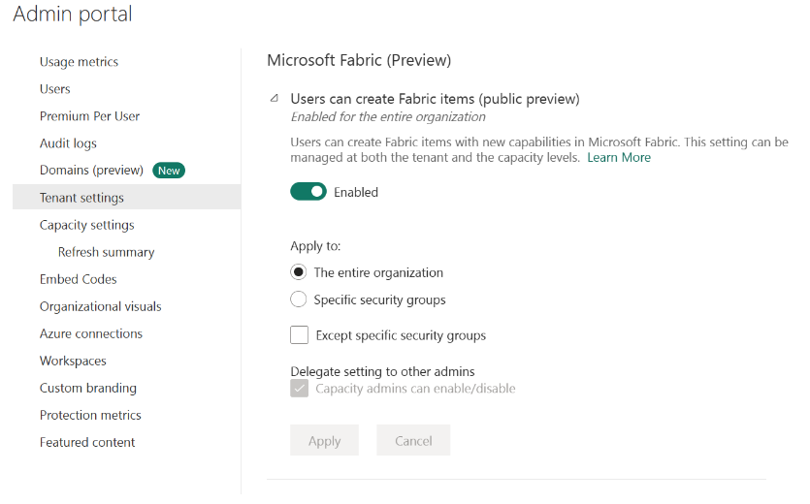

## **Create Fabric enabled workspaces**

All Fabric items (lakehouses, notebooks, pipelines, etc.) are stored in OneLake and accessed via Fabric workspaces.

Workspaces must be in Premium capacity to use Fabric. If you don't have access to Premium capacity, you aren't able to use Fabric. Select **Trial** in the **Premium capacity settings** section of the **Workspace settings** page to enable Premium capacity for your workspace.

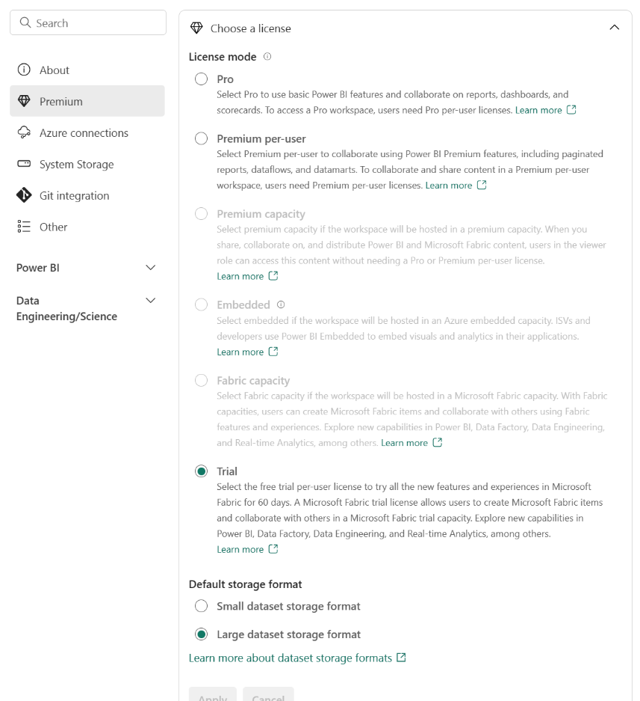

## **Create resources in Fabric**

After you've created your Fabric enabled workspace, you can start creating resources in Fabric. You can create resources in Fabric using the **Create** menu in the upper left corner of the Power BI service.

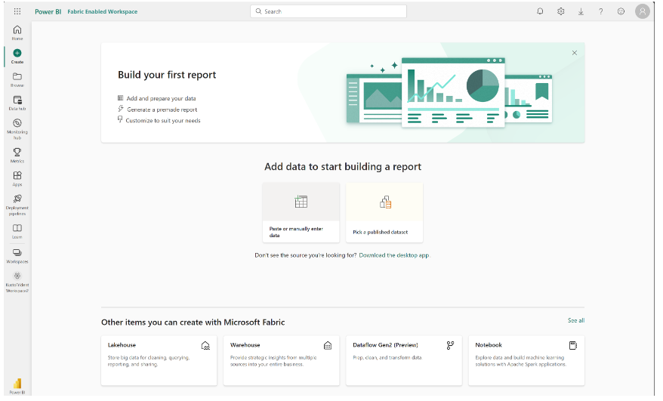

**Explore Fabric experiences**

Fabric experiences refer to the different capabilities included in Fabric. You can switch between experiences using the experience switcher in the bottom left corner of the navigation pane.

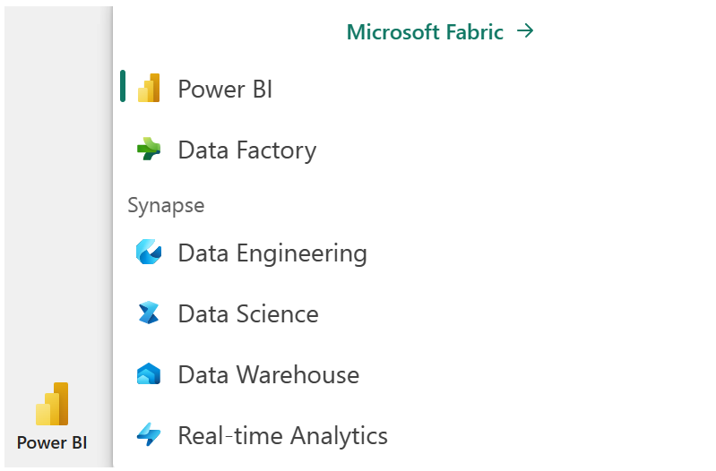

You may notice that Fabric experiences look similar to other Microsoft data offerings. Fabric is built on Power BI and Azure Data Lake Storage, and includes capabilities from Azure Synapse Analytics, Azure Data Factory, Azure Databricks, and Azure Machine Learning. What makes Fabric unique is that it brings these capabilities together in a single, SaaS, integrated experience without the need for access to Azure resources.

**Summary**

Data professionals are increasingly expected to be able to work with data at scale, and to be able to do so in a way that is secure, compliant, and cost-effective. At the same time, the business wants to use that data more effectively and quickly to make better decisions. Microsoft Fabric is a collection of tools and services that enables organizations to do just that. In this module, you learned about Fabric's OneLake storage, what workloads that are included in Fabric, and how to enable and use Fabric in your organization

